Callaway golf umbrella
*Superior Hydrophobicity: Plemo umbrella with high-density fabric and hydrophobic coating, water or rain will not soak through but sliding down quickly; exceptional water-repelling performance brings you peace of mind
*8 Fiberglass Ribs: High strength fiberglass boats excellent durability and resilience while 50% lightweight than iron ribs; built to last for years of protection
*Upgraded Construction: The newest honeycomb-like frame brings great resistance against even the high wind; automatic opening for added convenience
*Large Size: Opens up to 120 cm / 47.2 inches in diameter, providing enough shelter for 2 people; no worry about getting wet on rainy days
*Anti-slip Handle: unique tire-like texture design adds friction between your hand and the handle, enabling it will not slide off easily; comfortable to hold.聽
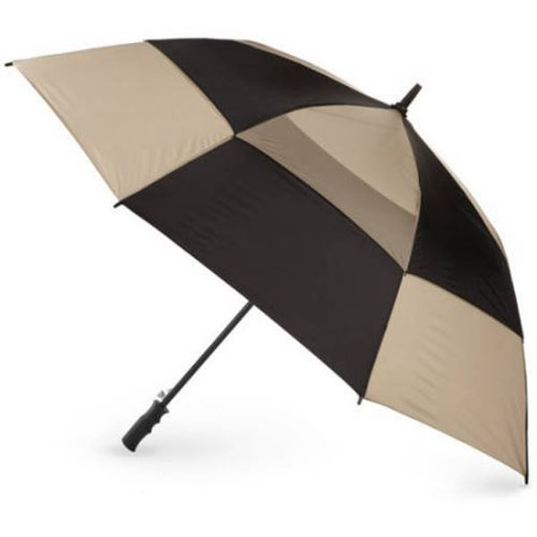
Company information
1998---A family business, a golf bag workshop, was founded, focusing on the local Chinese market.
2005---Moved to new 5000 square meter factory, employing 200 workers, with a production capability,
to produce 5000pcs per month.
2006---TH-SPORT (H.K.) was established, started to export our products world wide.
2008---Became partners with Grip, Glove, Cap & Umbrella factories.
2009---Started doing business with, Maxfli, Mercedes-Benz, Jaguar, Cleveland,Tommy Armour, Dunlop,
Hippo, Hello Kitty,Yamamoto, Ecco and a range of smaller companies.
2010---Opened a show room, to display all we have, on the pretty Xiamen Island, as a central convienent
location for our customers.
2016---We are focusing on developing high quality, innovative & fashionable golf products
Our Service
OUR ADVANTAGE:
1)We produce a range of High quality & fashionable products : We are consistently adding to our range, of
innovative & fashionable items. Having the highest quality is our first prority.
2) We are a Professional Manufacturer: we have been golf products manufacturer since 1998, we have a
wealth of experience.
3) Factory Price: You WILL benifit by our competitive pricing.
4)On time delivery: Being in manufacturing for more than 15 years, we have a wealth of experience, to control &
ensure, on time shipping .
5) Quality guarantee: Every order, we will offer a Pre production sample for quality confirmation before main production
FAQ
1.What is your main products?
Our main products are golf bag, headcover, club set, grip and other golf accessories, we offer OEM services.
2.What is your MOQ?
Our MOQ is usually 500 pcs
3.What is your time of making samples?
Usually we will take 2-3weeks to make the samples.

www.tt-sport.com

