Newest waterproof golf stand bag
1.Lightweight design at only 4.5 lbs;
2.heavy duty nylon construction ensures long lasting durability
3.club dividers keep clubs separated and secured
4.easy open/close magnetic ball pocket
5.Adjustable dual strap delivers the perfect fit for maximum carrying ease and comfort
6.Velour lined water-resistant valuables pocket
7.metal towel loop; Velcro glove holder; insulated cooler pocket
8.FREE PERSONALIZATION (ball pocket)

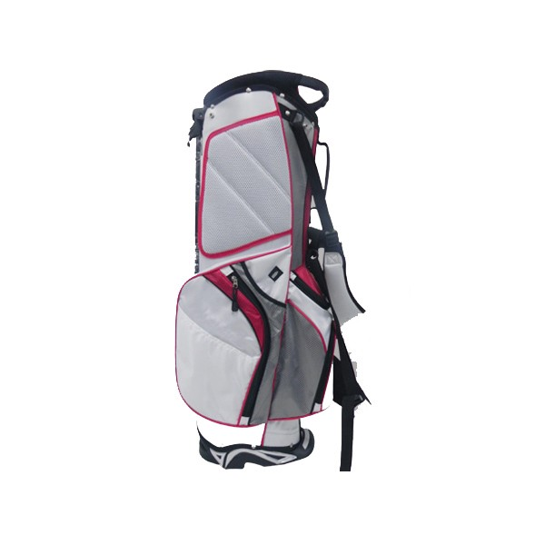
More information please click：www.tt-golf.com

